EXERCISE 3: STORED PROCEDURES

SCENARIO 1: The bank needs to process monthly interest for all savings accounts.

  - Question: Write a stored procedure ProcessMonthlyInterest that calculates and updates the balance of all savings accounts by applying an interest rate of 1% to the current balance.

CODE:

CREATE TABLE Accounts (
account_id NUMBER PRIMARY KEY,
account_type VARCHAR2(20),
balance NUMBER
);

-- Insert test data
INSERT INTO Accounts VALUES (101, 'Savings', 10000);
INSERT INTO Accounts VALUES (102, 'Current', 15000);
INSERT INTO Accounts VALUES (103, 'Savings', 20000);
COMMIT;

SELECT * FROM Accounts;

CREATE OR REPLACE PROCEDURE ProcessMonthlyInterest IS

BEGIN
UPDATE Accounts
SET balance = balance + (balance * 0.01)
WHERE account_type = 'Savings';

COMMIT;
DBMS_OUTPUT.PUT_LINE('Monthly interest applied to savings accounts.');
END;
/
-- Call the procedure
BEGIN
ProcessMonthlyInterest;
END;
/
SELECT * FROM Accounts;

- USING OneCompiler
OUTPUT:
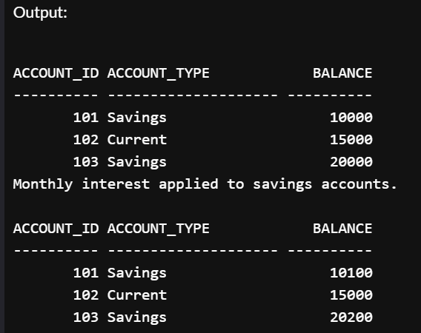
SCENARIO 2: The bank wants to implement a bonus scheme for employees based on their performance.
  - Question: Write a stored procedure UpdateEmployeeBonus that updates the salary of employees in a given department by adding a bonus percentage passed as a parameter.

CODE:

CREATE TABLE Employees (
emp_id NUMBER PRIMARY KEY,
emp_name VARCHAR2(50),
department_id NUMBER,
salary NUMBER
);

-- Insert sample data
INSERT INTO Employees VALUES (1, 'John', 10, 30000);
INSERT INTO Employees VALUES (2, 'Mary', 20, 40000);
INSERT INTO Employees VALUES (3, 'Alex', 10, 50000);
COMMIT;

SELECT * FROM Employees;

CREATE OR REPLACE PROCEDURE UpdateEmployeeBonus (
p_dept_id IN NUMBER,
p_bonus_pct IN NUMBER
) IS
BEGIN
UPDATE Employees
SET salary = salary + (salary * p_bonus_pct / 100)
WHERE department_id = p_dept_id;

COMMIT;
DBMS_OUTPUT.PUT_LINE('Bonus applied to department ID ' || p_dept_id);
END;
/
BEGIN
UpdateEmployeeBonus(10, 10); -- 10% bonus to dept 10
END;
/

OUTPUT:
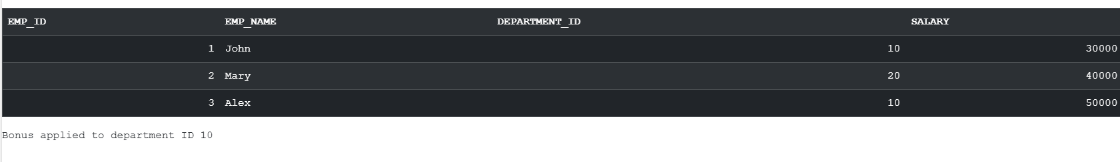
SCENARIO 3: Customers should be able to transfer funds between their accounts.

  - Question: Write a stored procedure TransferFunds that transfers a specified amount from one account to another, checking that the source account has sufficient balance before making the transfer.

CODE:

-- Step 1: Create table
CREATE TABLE Accounts (
account_id NUMBER PRIMARY KEY,
account_type VARCHAR2(20),
balance NUMBER
);

-- Step 2: Insert data
INSERT INTO Accounts VALUES (104, 'Savings', 8000);
INSERT INTO Accounts VALUES (105, 'Savings', 3000);
COMMIT;

-- Step 3: Create procedure
CREATE OR REPLACE PROCEDURE TransferFunds (
p_from_acc_id IN NUMBER,
p_to_acc_id IN NUMBER,
p_amount IN NUMBER
) IS
v_balance NUMBER;
BEGIN
-- Check balance
SELECT balance INTO v_balance
FROM Accounts
WHERE account_id = p_from_acc_id;

IF v_balance < p_amount THEN
DBMS_OUTPUT.PUT_LINE('❌ Transfer failed: Insufficient balance.');
RETURN;
END IF;

-- Perform transfer
UPDATE Accounts
SET balance = balance - p_amount
WHERE account_id = p_from_acc_id;

UPDATE Accounts
SET balance = balance + p_amount
WHERE account_id = p_to_acc_id;

COMMIT;
DBMS_OUTPUT.PUT_LINE('Transfer of ' || p_amount || ' completed.');
END;
/
-- Step 4: Call the procedure
BEGIN
TransferFunds(104, 105, 2000);
END;
/
SELECT * FROM Accounts;

OUTPUT:
